Lesson 5 Demo 5
Integrate Ant with Jenkins

Objective: Install Ant plugin and integrate it with Jenkins

Tools required: Git, GitHub, and Jenkins

Prerequisite: Please ensure you have jenkins installed in order to proceed. In case you don’t have it installed, you can refer to demo 1 of lesson 5 to install jenkins.

Steps to be followed:
- Create a GitHub repository
- Add build.xml file to the repository
- Set the Global Tool Configuration
- Integrate Ant with Jenkins

Step 1: Create a GitHub repository
  - Open the browser in the lab.

  - Go to https://github.com/ link.
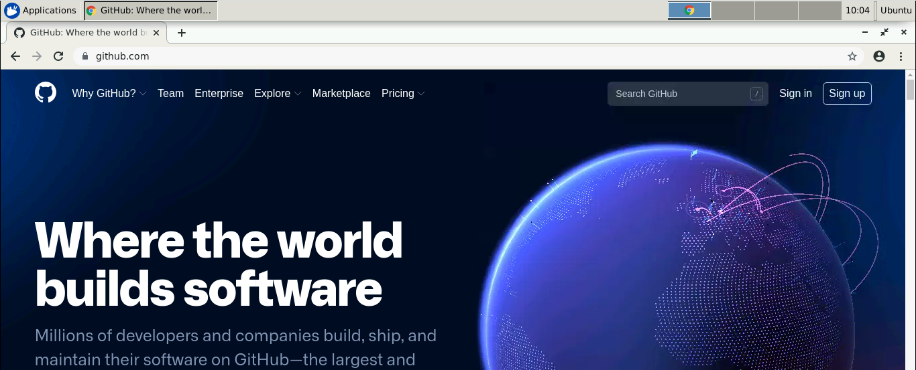

  - Click on Sign in and enter the credentials of your GitHub account to login.
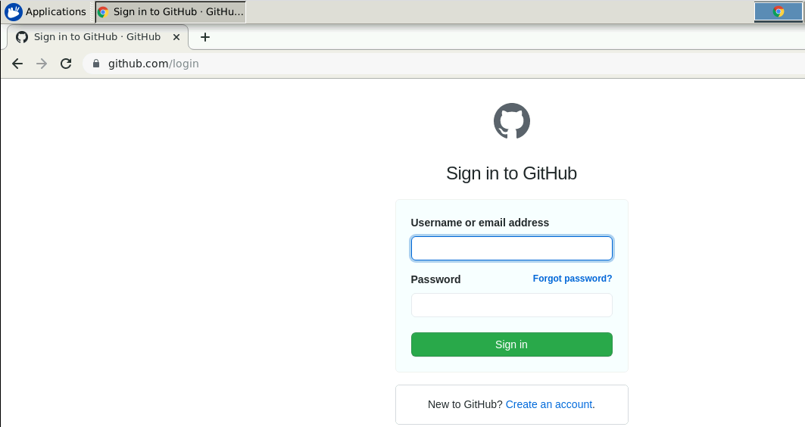

  - Click on + symbol and select New repository.
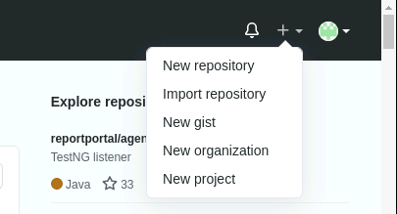

  - Provide the repository name.
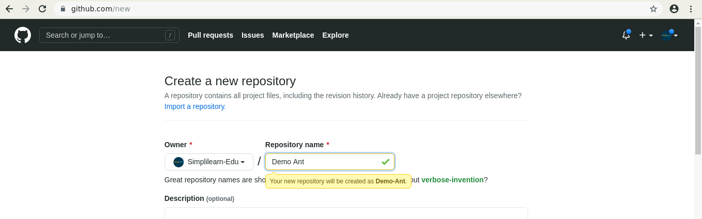

  - Select the check box of ADD a README file and click on Create repository.
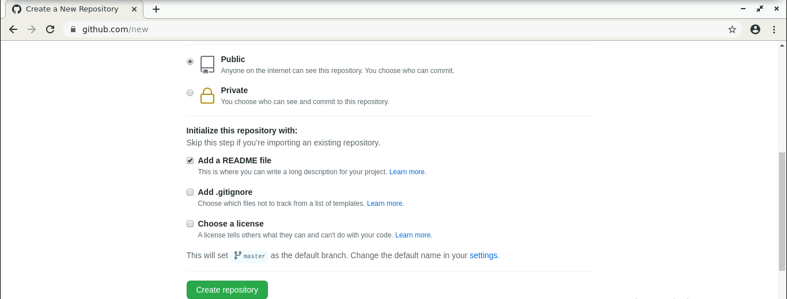

  - Click on Code.
  - Click on HTTPS.
  - Copy the repository URL.
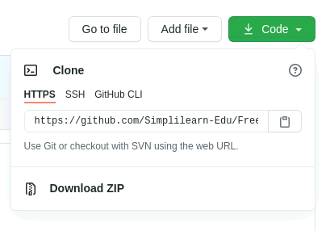

Step 2: Add build.xml file to the repository

  - Open the terminal.
  - Run mkdir helloworld to create a directory.
  - Navigate to the hello-world directory. Run cd helloworld command.
  - Run vi build.xml to open the java file in a text editor.
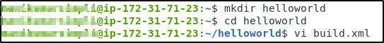

2.5 Paste the code below into the file:

<?xml version="1.0"?>
<project name="Hello World Project" default="info">
<target name="info">
<echo> Hello World - Welcome to Simplilearn</echo>
</target>
</project>
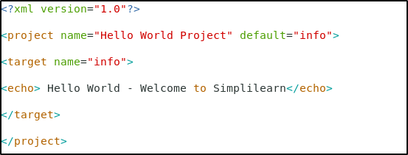

  - Save the file and exit the text editor.

  - Run the git init command.
  - Run git add . command.
  - Run git commit -m “Add new files” command.

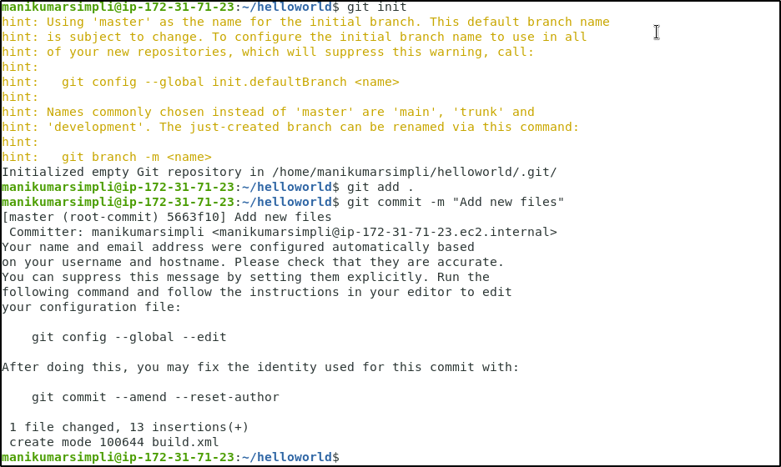

  - Run git remote add origin <Repository_URL> command.
  - Run git push -u origin master command.

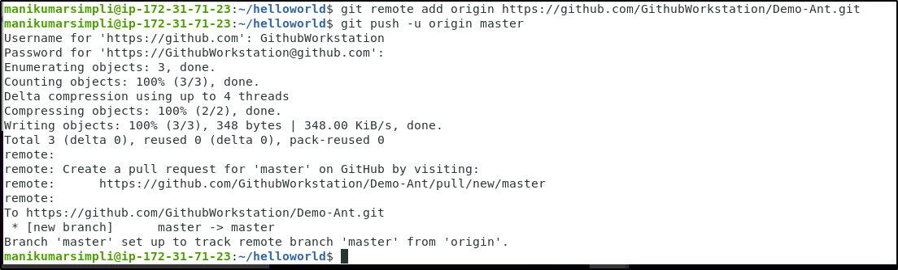

Step 3: Set the Global Tool Configuration
  - Open the browser and go to Jenkins dashboard by typing localhost:8080 in your browser.
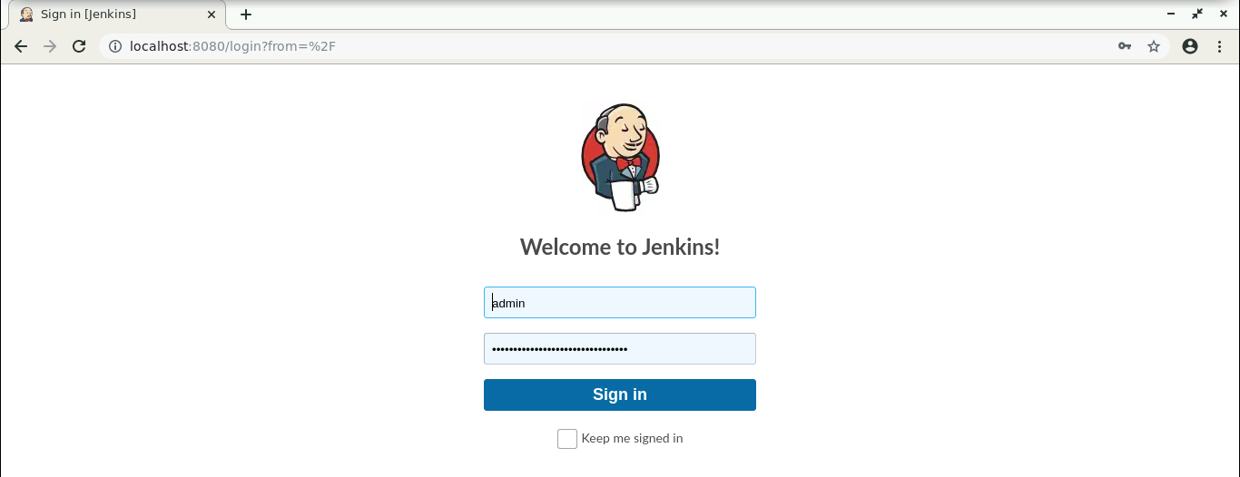

  - Provide the credentials and click on Sign in.
  - Go to Jenkins Dashboard, click on Manage Jenkins. From the list of options, choose Global Tool Configuration.
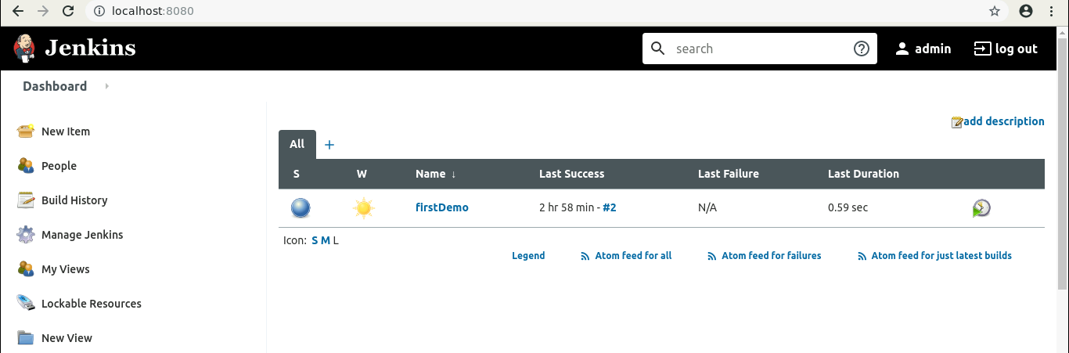

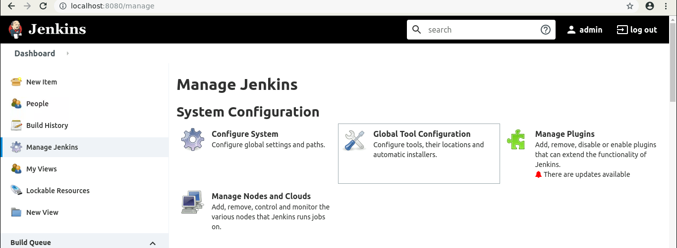

  - Click on Add Ant, provide the Name, and select the version you want to install. And check the Install automatically checkbox.

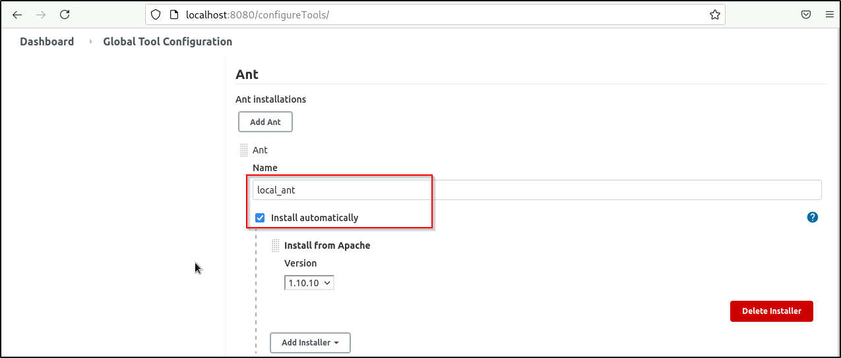

  - Click on Save.

Step 4: Integrate Ant with Jenkins
  - Click on New Item in the Jenkins dashboard.
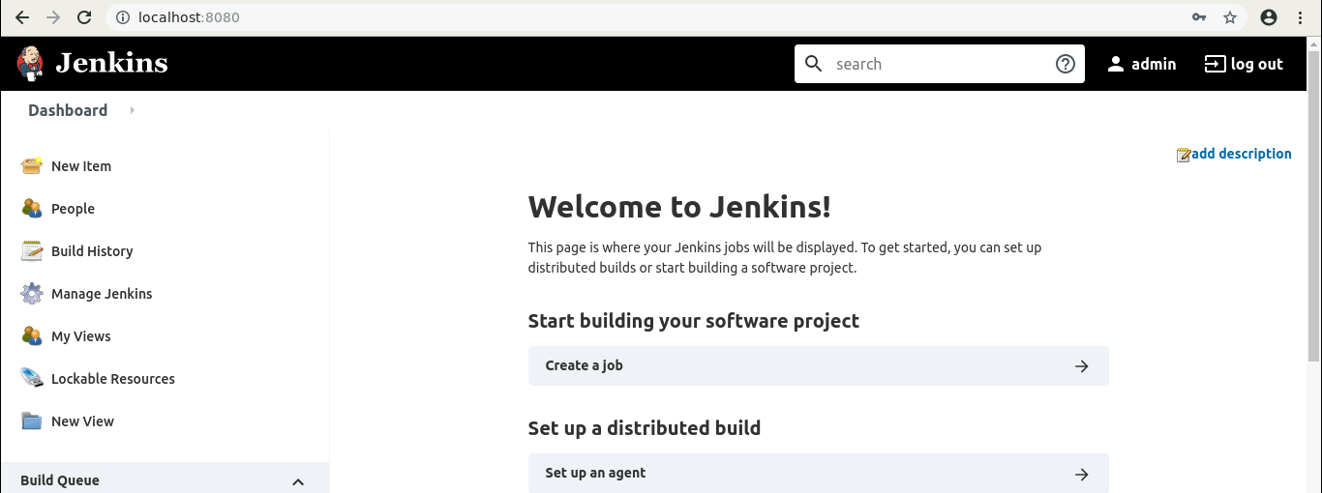

  - Enter a name for your project.
  - Select the Freestyle project as the build job type.
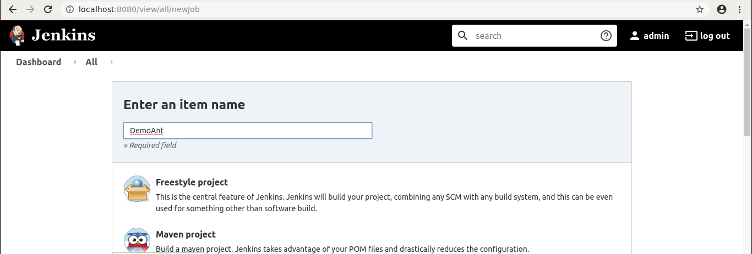

  - Click on OK.
  - Scroll down to the Source Code Management section and select Git.
  - Enter the repository URL.
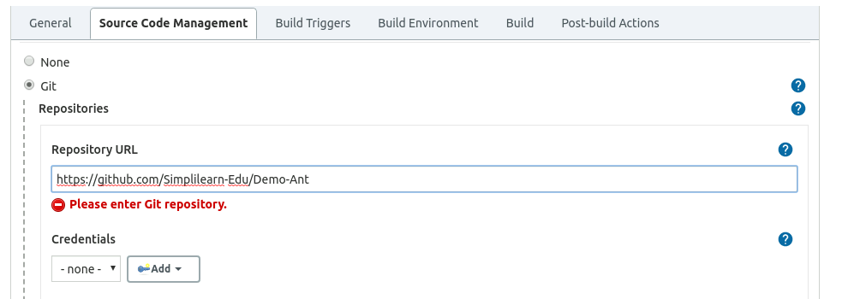

  - In the Build section, click on the Add build step option and select Invoke Ant.
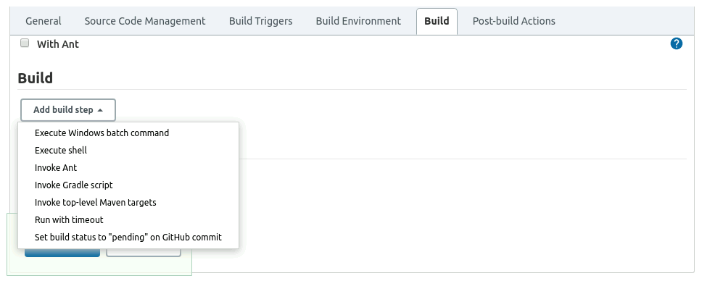

  - Select the Ant version you want to work on.
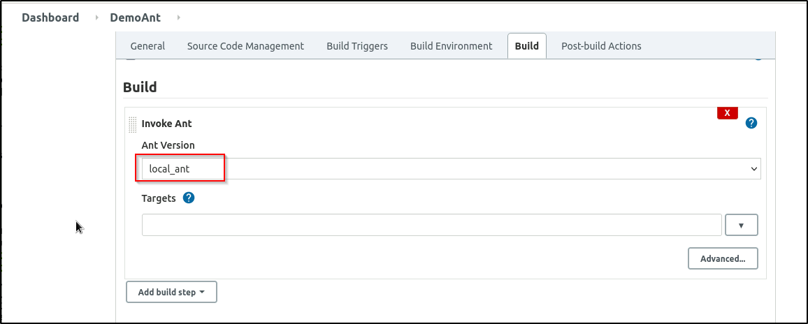
  - Click on Save.

  - Click on Build Now.
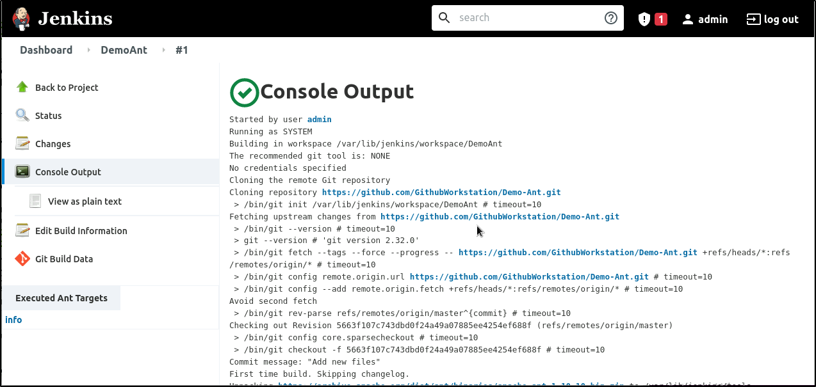

  - Click on the Build History to view the build results.
  - Click on the Console Output to view the build logs.

